**DAILY ONLINE ACTIVITIES SUMMARY**

|  |  |  |  |  |  |  |  |  |
| --- | --- | --- | --- | --- | --- | --- | --- | --- |
| **Date:** |  | **18-05-2020** | | |  | **Name:** | **Spoorthi ms** | |
|  |  |  |  |  |  |  |  |  |
| **Sem & Sec** |  | **VI B** | | |  | **USN:** | **4AL17CS097** | |
|  |  |  |  |  |  |  |  |  |
|  |  |  |  | **Online Test Summary** | | |  |  |
|  | |  |  |  |  |  |  |  |
| **Subject** | |  | **CNSC IA Test** | |  |  |  |  |
|  | |  |  |  |  | |  |  |
| **Max. Marks** | |  | **60** |  | **Score** | | **56** |  |
|  |  |  |  |  |  | |  |  |
|  |  |  |  | **Certification Course Summary** | | | | |
|  | |  | |  |  | |  |  |
| **Course** |  | **Web Development with Python and Javascript** | | | | |  |  |
|  |  | | |  |  | |  |  |
| **Certificate Provider** | | | | **Harvard University** | **Duration** | |  | **12weeks** |
|  |  |  |  |  |  | |  |  |
|  |  |  |  | **Coding Challenges** | | |  |  |

**Problem Statement:**

**1.** Using methods charAt() & length() of String class, write a program to print the frequency ofeach character in a string.

**2.** Write down a java program to print even and odd numbers series respectively from twothreads: t1 and t2 synchronizing on a shared object

Let t1 print message “ping — >” and t2 print message “,—-pong”.

**Status:Completed**

|  |  |  |  |
| --- | --- | --- | --- |
| **Uploaded the report in Github** |  | **Yes** | |
|  |  |  | |
| **If yes Repository name** |  | **https://github.com/msspoorthi/Web-development-with-Python-java-script** | |
|  |  |  |  |
| **Uploaded the report in slack** |  | **Yes** | |
|  |  |  |  |

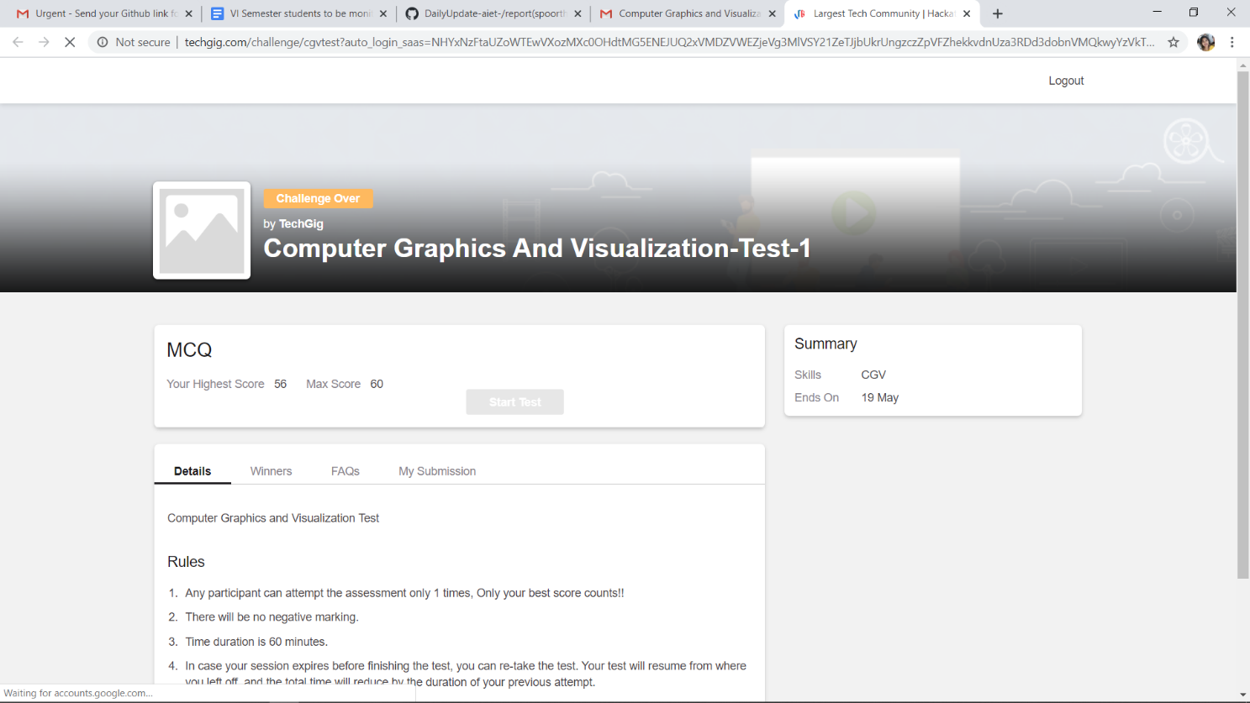

**Online Certification Details**

Lesson-1

* Learning about Git

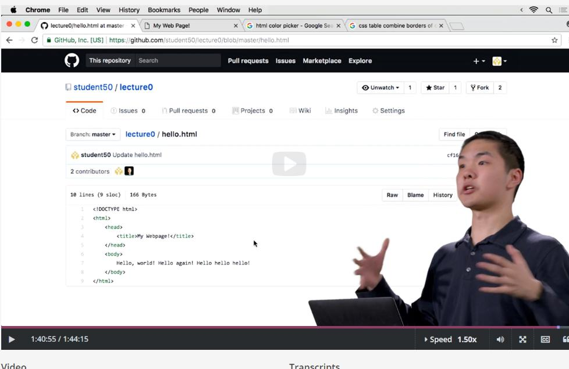

**Coding Challenge Details**

**1.** Using methods charAt() & length() of String class, write a program to print the frequency of each character in a string.

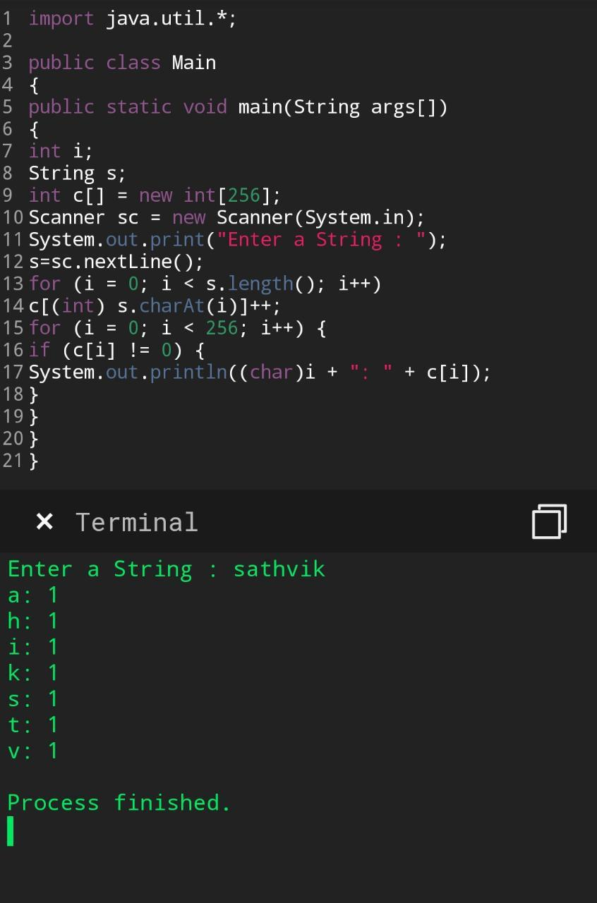

1. Write down a java program to print even and odd numbers series respectively from two threads: t1 and t2 synchronizing on a shared object

Let t1 print message “ping — >” and t2 print message “,—-pong”.

